National University of Computer and Emerging Sciences



Assignment 1.1 & 1.2

Computer Organization and Assembly Language

|  |  |
| --- | --- |
| Name | Muhammad Zain |
| Roll No. | 19F-0228 |
| Lab Instructors | Mr Abuzar Ghfari |
| Semester | Fall 2020 |

Lab 1.1

Problem 1

**MOV AX, 21D                              AX = 0015**

**MOV AH, 10                                 AX = 0A15**

**MOV BX, 001100B                       BX =000C**

**MOV CX, 9A00H                          CX = 9A00**

**MOV CL, -10                                 CX =9AF6**

**MOV AL, 5                                    AX =0A05**

**MOV BL, -5                                   BX =00FB**

**ADD AL, BL                                  AX =0A00**

**MOV CH, 24                                  CX =18F6**

**MOV BL, 12                                  BX =000C**

**SUB CH, BL                                   CX =0CF6**

**MOV AH, ‘2’                                 AX =0C00**

**MOV AL, ‘4’                                  AX =0C0C**

**XCHG AH, AL                               AX =0C32**

Problem 2:

**NAME "Simple Addition Subtraction"**

**.model small**

**.stack 100h**

**.data**

**.code**

**MOV AX, 5**

**MOV BX, 10**

**ADD AX, BX**

**ADD AX, 15**

**SUB AX, 20**

**ADD AX, 15**

**ADD AX,10**

**ADD AX,5**

**mov ah,04ch**

**int 21h**

Output:

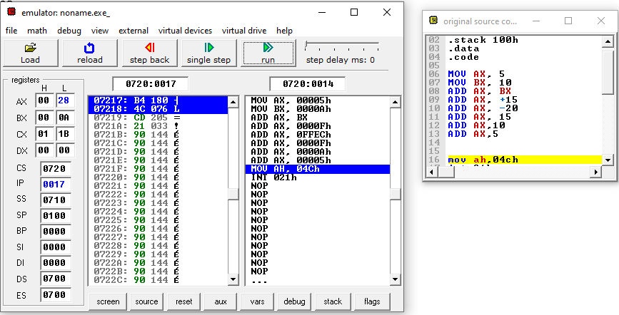

**Problem 3**:

**NAME "ZAIN"**

**.MODEL SMALL**

**.STACK 100H**

**.DATA**

**.CODE**

**MOV AX, 5AH**

**MOV BX, 41H**

**MOV CX, 49H**

**MOV DX, 4EH**

**ADD AX, BX**

**ADD AX, CX**

**ADD AX, DX**

**MOV AH, 4CH**

**INT 21H**

Output:

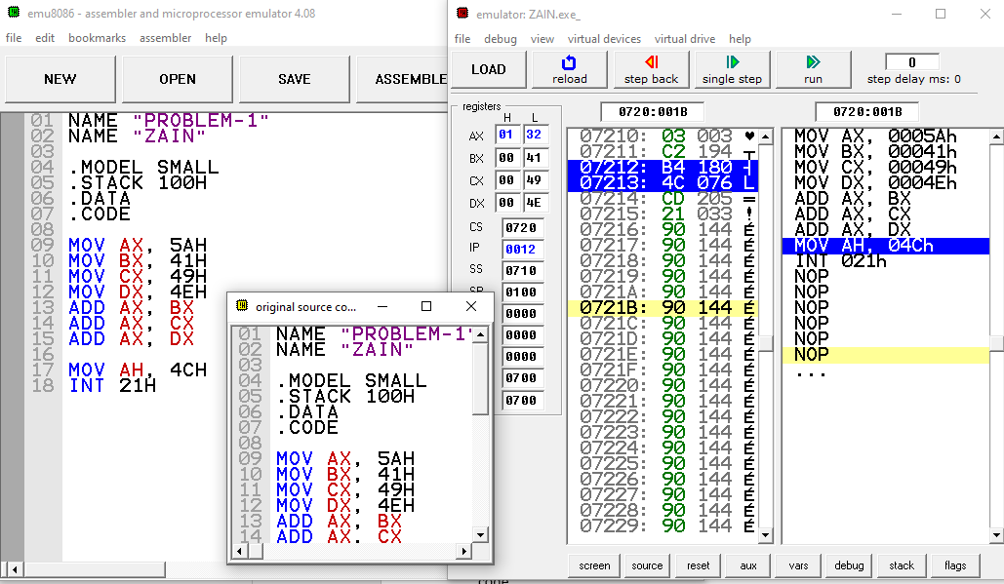

Lab 1.2

Problem 1

**NAME "Subtraction and Addition"**

**.model small**

**.stack 100h**

**.data**

**.code**

**MOV AX, 5**

**MOV BX, 10**

**ADD AX, BX**

**SUB AX, 3**

**SUB AX, 3**

**ADD AX, 5**

**ADD AX, 10**

**SUB AX, 3**

**SUB AX, 3**

**ADD AX, 5**

**ADD AX,10**

**mov ah,04ch**

**int 21h**

Output:



